SRM INSTITUTE OF SCIENCE AND TECHNOLOGY
SCHOOL OF COMPUTING
21CSP302L – IIIrd Year PROJECT - 2026
VI Semester
Syllabus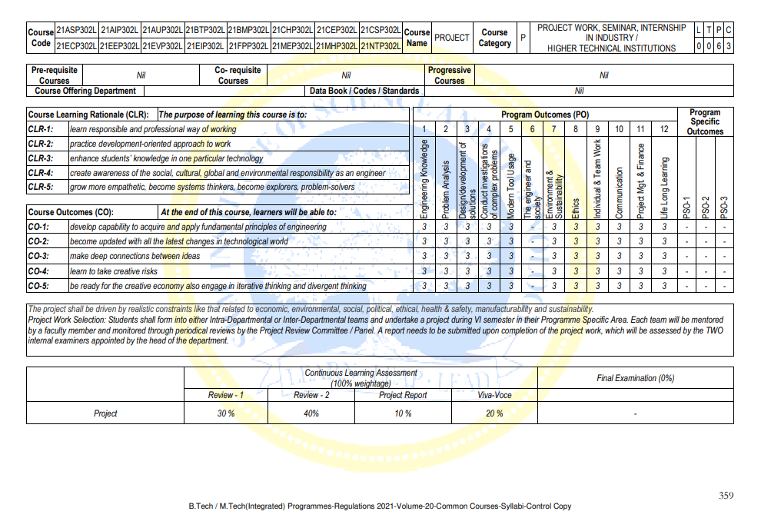

REVIEW SCHEDULE
REVIEW | DATES
Project Review – I | 21.02.2026 Saturday
Project Review - II | 22.03.2026 Saturday
Project Report Evaluation, Demo with Viva voce | April 28-30,2025

Instructions for Product-Oriented Projects
- Students must provide a brief introduction to their projects along with a short abstract.
(Students are encouraged to choose their problem statements from tech challenges, industry use cases, or societal issues. Projects leveraging emerging technologies are highly encouraged.)
- For product-oriented projects, students should work in teams and assume the roles of Product Owner, Scrum Master, and Developer. Each team member will be responsible for their assigned role. Teams will use Agile boards to update, track, and manage tasks as they progress. Each role will contribute to maintaining and updating the board to accurately reflect the project's status.
- They must prepare a vision statement that outlines the product's purpose, target audience, and long-term impact. The vision statement should inspire stakeholders and provide clear direction for the product’s development. (Template attached.)
- The student team must create a detailed product backlog, including epics, sprints, prioritization, and functional and non-functional requirements, along with a product roadmap/Release Plan. Also Prepare the system architecture. (Templates attached)
- Students are encouraged to work on their projects as a team. Each project team must consist of a minimum of two and a maximum of four students.
- The project should align with one of the prominent Sustainable Development Goals (SDGs) listed on Page 7, ideally focusing on SRMIST themes like Water, Energy, Environment, Healthcare, or Disruptive Technologies.
Instructions for Research-Oriented Projects

- Students must provide a brief introduction to their projects along with a short abstract.
(Students are encouraged to identify their research problems by referring to standard journals and analyzing the latest and emerging research trends)
- Students should review 15–20 research papers from reputed journals and conduct a comprehensive literature survey. They must identify research gaps and limitations by adhering to the provided template.
S. No | Title  (Name of the journal, author and publication details) | Methodology  (Provide a Summary of key studies and their findings) | Identification of gaps and limitations.  (Identify the limitations of the Research Paper)
1 | Chatterjee, N., Agarwal, R., 2023. Studying the effect of syntactic simplification on text summarization. IETE Techn. Rev. (Inst. Electron. Telecommun. Eng., India) 40 (2), 155–166 | - Grammatical structure and sentence formation  - Part-of-speech tagging, dependency parsing  - Grammatical correctness | - May lack complete meaning and understanding  - Less adept at handling nuanced semantic information  - Can struggle with ambiguity and context
2

- Students should identify the objectives of their research projects, with each objective considered an "Epic”. They should create a detailed product backlog, including epics, sprints, prioritization, and functional and non-functional requirements (Templates attached)
- Unlike product-oriented projects, students do not need to take on roles such as product owner, Scrum master, or developer. Instead, they can apply agile practices by crafting effective user stories from a researcher's perspective. Teams will use Agile boards to update, track, and manage tasks as they progress. Each role will contribute to maintaining and updating the board to reflect the project's status
- The student team must prepare an architectural document by selecting the methodology and justifying the most suitable architecture for their project, such as Microservices, Event-Driven Architecture, Serverless, or Monolithic Architecture. They should provide a detailed explanation and create relevant diagrams, including use case, class, DFD, component, sequence, and deployment diagrams, to support their project.
- Students are encouraged to work on their projects as a team. Each project team must consist of a minimum of two and a maximum of four students.
- The project should align with one of the prominent Sustainable Development Goals (SDGs) listed on Page 7, ideally focusing on SRMIST themes like Water, Energy, Environment, Healthcare, or Disruptive Technologies.
Note: 1. All the projects must be published as research article /patented within this academic year. Publishing or patenting of project work is the responsibility of the students and the guide.
2. Students must fill in all necessary project details, including objectives and expected outcomes, in the project validation forms and submit them to the panel members during the review.

REVIEW 1 - WORK TO BE COMPLETED

REVIEW DETAILS | DATES  (Tentative) | WORK TO BE COMPLETED (Research Projects) | WORK TO BE COMPLETED (Product-based Projects)
Project Review – 1 | 21 February 2026 | Abstract  Introduction to project  Literature survey in table format (Template attached)  Limitations identified from Literature Survey (Research Gaps)  Research objectives (Can be considered as epics and prepare product backlog)  Identify the technique to implement the objectives  Architecture Document  Justification of Project SDG  Plan of action (Timeline) | Abstract  Introduction to project  Product Vision Statement (Template Attached)  Prepare a Detailed Product Backlog (Template Attached)  (The student team needs to prepare a detailed product backlog that consists of epics, sprints, prioritization, functional, and non-functional requirements.)  Architecture Document  Justification of Project SDG  Product Road Map (Timeline)

SUSTAINABLE DEVELOPMENT GOALS (SDGS)
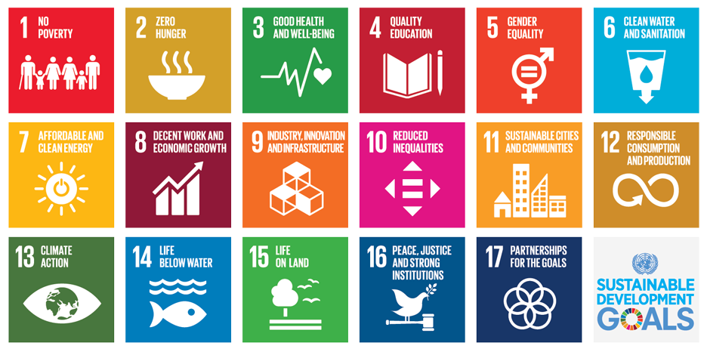

All official project communications will be sent to the students from the following email address.
Official Mail id: scoagile.workgroup@srmist.edu.in

MARKS SPLIT UP FOR THE FIRST REVIEW – 21CSP302L PROJECT
#R1 : Rubrics for Review 1
Maximum Marks : 30
PI Code | PI | Parameter | Marks | Excellent  (24-30) | Good  (16 -23) | Average  (9-15) | Poor  (0-8)
1.6.1 | Apply engineering fundamentals-GA | Problem Formulation after Literature Survey or Product Market Analysis | 5 | The problem is clearly defined with a well-articulated scope and effectively addresses the gaps identified through the literature survey or product market analysis(5) | Problem is generally defined with a clear scope but may only partially address the gaps identified in the literature survey or market analysis.(4) | Problem is vaguely defined with an unclear scope, and only a few of the gaps identified in the literature survey or market analysis are addressed.(3) | Problem is poorly defined with no clear scope, and does not adequately address the gaps identified in the literature survey or market analysis.(2)
4.4.1 | Define a problem for purposes of investigation, its scope and importance-GA
2.5.1 | Evaluate problem statements and identifies objectives-GA | Evaluate Problem statement and set Objectives / Product Vision Statement | 4 | Problem statement is clear, specific, and well-aligned with objectives or product vision that are measurable, achievable, and directly address key issues.(4) | Problem statement is clear with minor gaps in specificity, and objectives/product vision are generally aligned but require full clarity.(3) | The problem statement is inadequate in detail, and the objectives or product vision are either unclear or not well-aligned with the identified issue.(2) | Problem statement and objectives/product vision are poorly defined (1)
2.5.2 | Identify processes/modules/algorithms of a computer-based system and parameters to solve a problem-GA | Identify processes / Features | 4 | Processes or features are thoroughly identified, well-organized, and directly contribute to achieving the project’s objectives, with clear prioritization and feasibility.(4) | Processes or features are well-identified and generally support the project’s objectives (3) | Processes or features are identified but lack structure, organization, or alignment with project objectives.(2) | Processes or features are poorly identified, and do not align with the project’s objectives  (1)
3.6.1 | Able to explore design alternatives.-IA | Explore design alternatives and Develop a risk free Design | 4 | Multiple innovative design alternatives are explored with in-depth comparison and proposed a well-developed, risk-free design(4) | A few design alternatives are explored with reasonable comparison, and a generally risk-free design is proposed(3) | A limited set of design alternatives are explored with minimal comparison, and the design addresses some risks(2) | No meaningful design alternatives are explored, and the design lacks consideration of potential risks(1)
7.3.1 | Identify risks/impacts in the life-cycle of an engineering product or activity-GA
11.6.2 | Use project management tools to schedule an engineering project, so it is completed on time and on budget.-GA | Prepare a Plan of Action/ Road Map | 2 | A clear, detailed, and realistic plan of action is presented, with well-defined milestones, timelines, and resource allocation that align perfectly with the project goals.(2) | A solid plan of action is presented with clear milestones and timelines, though some minor details or resources may not be fully addressed. (1.5) | A plan of action is outlined but lacks clear milestones, timelines, or resource(1) | incomplete plan of action with unclear milestones, timelines(0.5)
7.3.2 | Understand the relationship between the technical, socio-economic and environmental dimensions of sustainability - GA | Project mapping with SDG | 3 | Strongly Understand the relationship between the technical, socio-economic and environmental dimensions of sustainability and mapped with SDG(3) | Understand the relationship between the technical, socio-economic and environmental dimensions of sustainability and mapped with SDG(2.5) | With minimal understanding Mapped with SDG (1) | With out understanding Mapped with SDG (0.5)
10.5.2 | Deliver effective oral presentations to technical and non-technical audiences-IA | Technical Presentation | 4 | The presentation is highly organized, clear, and engaging, with in-depth technical content, well-supported by visuals.(4) | The presentation is well-organized, clear, and covers the key technical points, though some parts could use better explanation or visuals.(3) | The presentation is somewhat organized, but some sections lack clarity or sufficient technical detail, and visuals may be lacking.(2) | Presentation was prepared and attempted (1)
10.4.2 | Produce clear, well-constructed, and well-supported written engineering documents-GA | Technical Documentation * | 4 | The document is exceptionally clear, well-organized, and thoroughly supported with strong technical content, citations, and data, demonstrating a high level of professionalism and accuracy.(4) | The document is clear, well-organized, and adequately supported with technical content and references (3) | The document lacks some clarity, organization, or depth, with limited supporting content or citations and some errors.(2) | The document is poorly organized, and lacks sufficient technical support or citations (1)
GA – Group Assessment IA – Individual Assessment
Marks specified in the brackets are the maximum marks that can be gained if the student satisfy the relevant descriptor.

Guidelines for Generating Technical Document with AI support*

Utilize AI for Information Gathering: Students can use AI to collect relevant data and technical details for documentation; however, the information should be articulated by them according to the flow of work and the structure of the document.
Verify Accuracy and Reliability: AI may produce inaccurate or biased information. Always verify the facts and relevance of AI-generated content before including it in the final documentation.
Fact-Check AI Content: Double-check AI-generated content for factual accuracy by validating data, claims, and conclusions through trusted and reliable sources to maintain the document's integrity.
Follow Citation Guidelines: Students must properly cite all external sources, whether referred by them or AI, following the required citation style.

